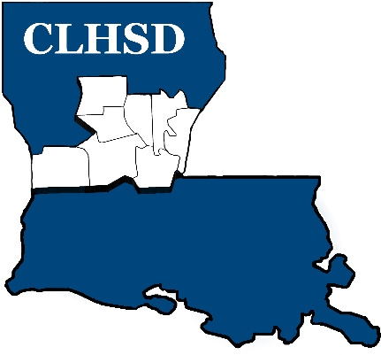

PUBLIC NOTICE

The Board of Directors of Central La Human Services District will conduct its monthly meeting on:

Thursday, December 2nd
5:30 p.m.

5411 Coliseum Blvd.
Alexandria, LA

The meeting is open to the public

